MobileTestingScenario_runTestScenario_Instance3_06-Apr-2016_09-07-20_AM_Staging_Page_Navigation.png

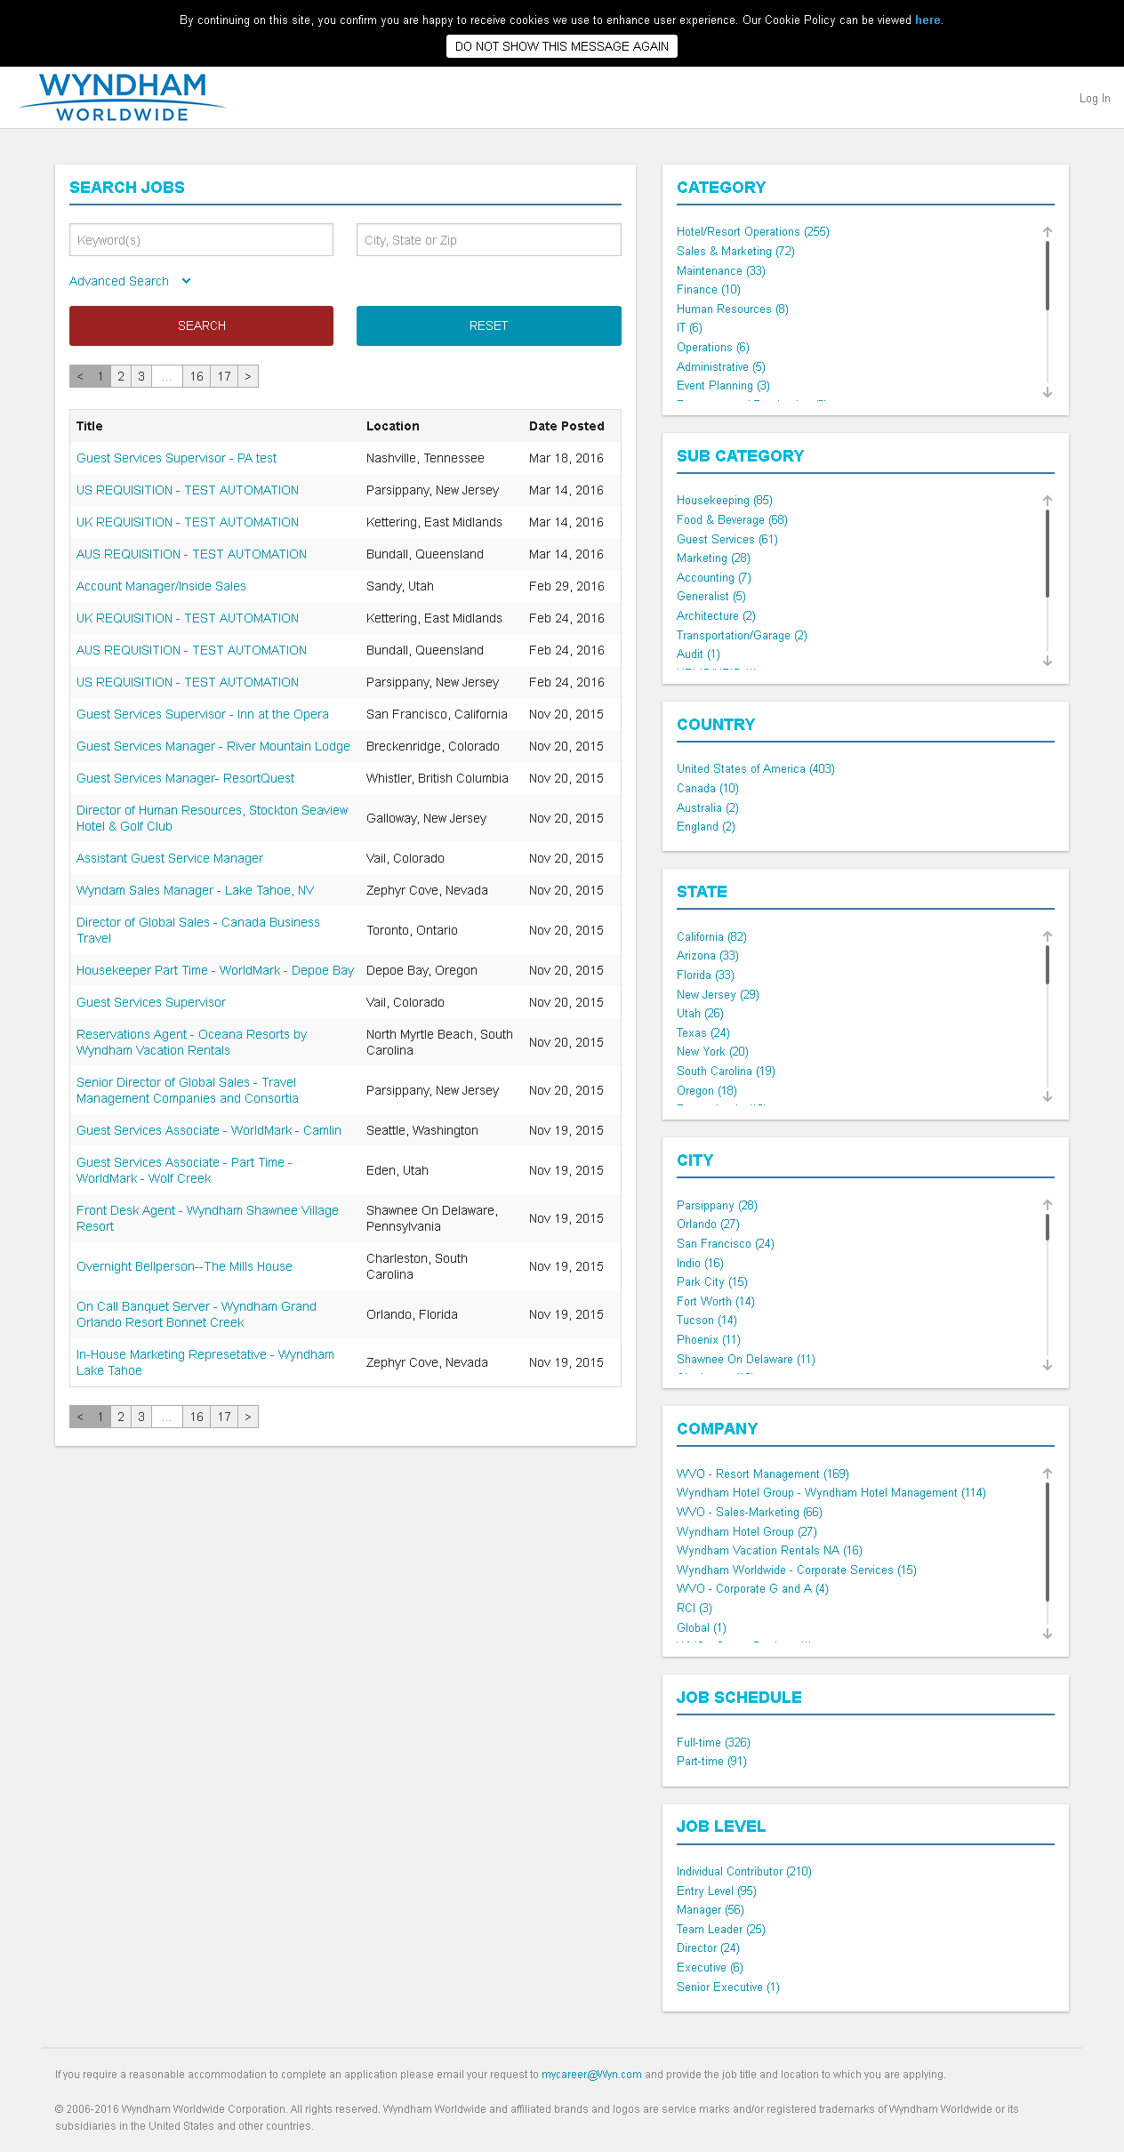

MobileTestingScenario_runTestScenario_Instance3_06-Apr-2016_09-08-12_AM_Create_Account.png

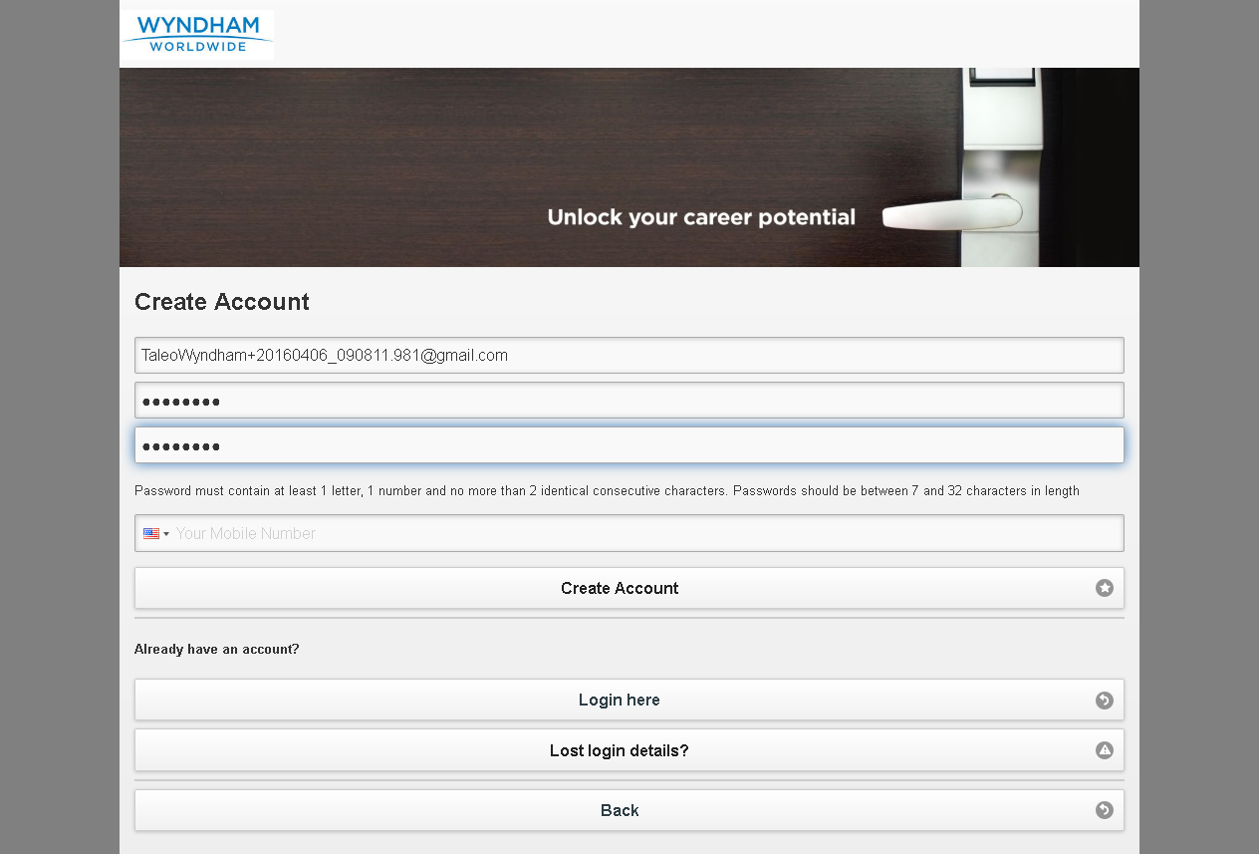

MobileTestingScenario_runTestScenario_Instance3_06-Apr-2016_09-08-30_AM_Continue.png

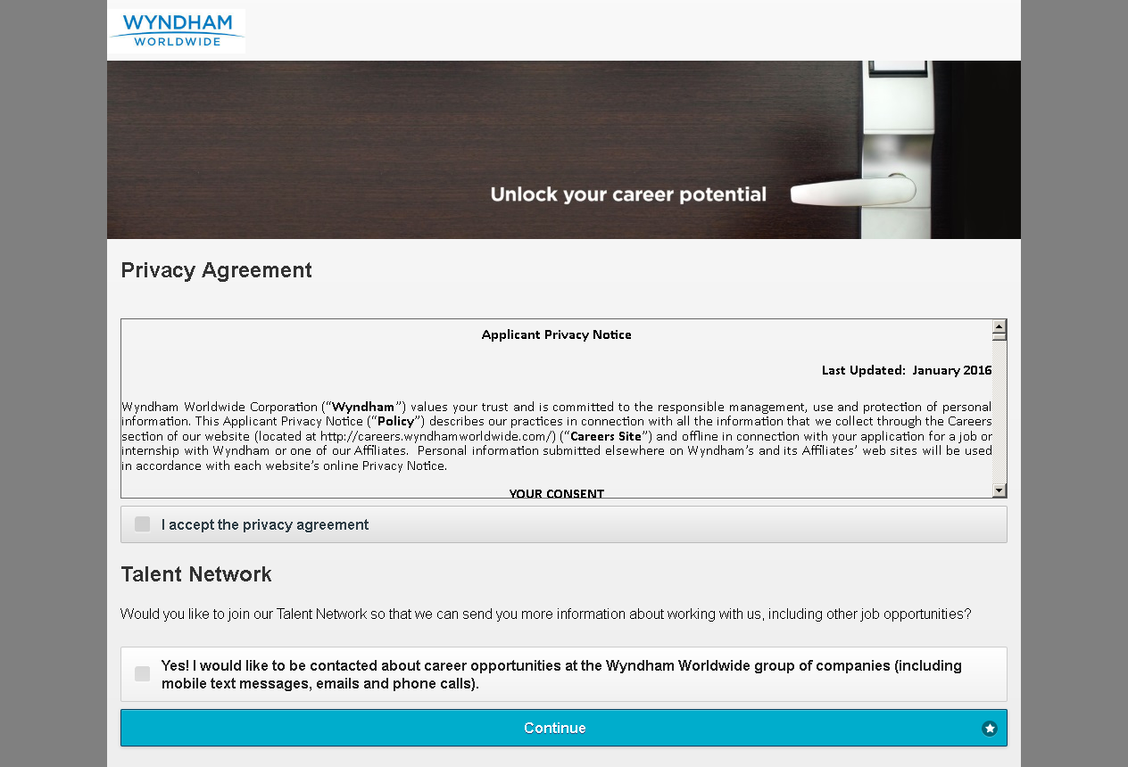

MobileTestingScenario_runTestScenario_Instance3_06-Apr-2016_09-08-30_AM_Create_Account.png



MobileTestingScenario_runTestScenario_Instance3_06-Apr-2016_09-08-36_AM_privacyAgreement.png

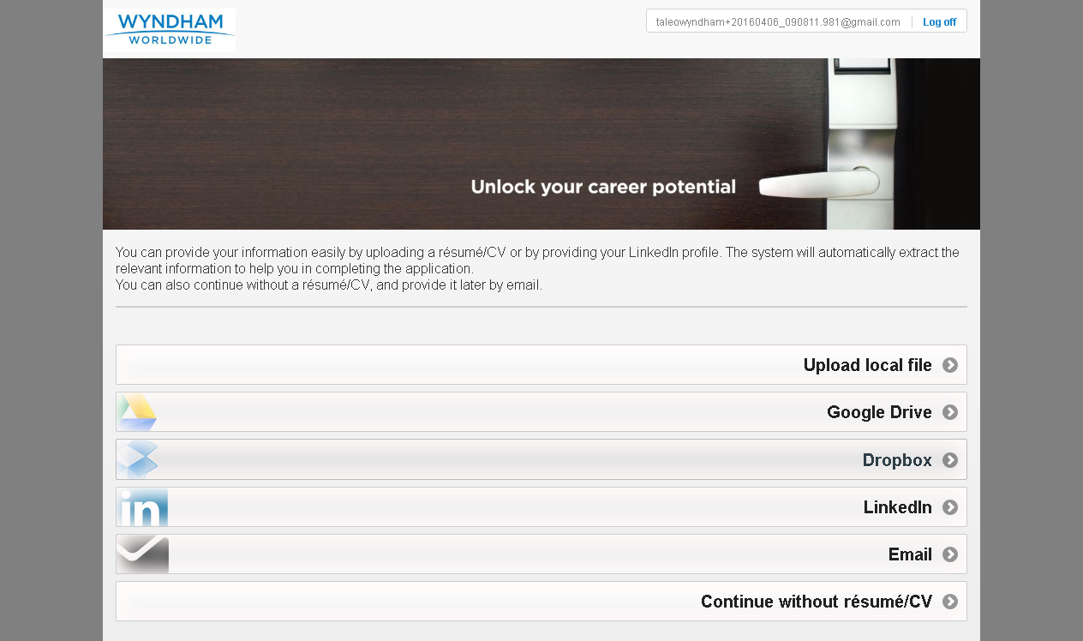

MobileTestingScenario_runTestScenario_Instance3_06-Apr-2016_09-08-37_AM_Resume_Option.png

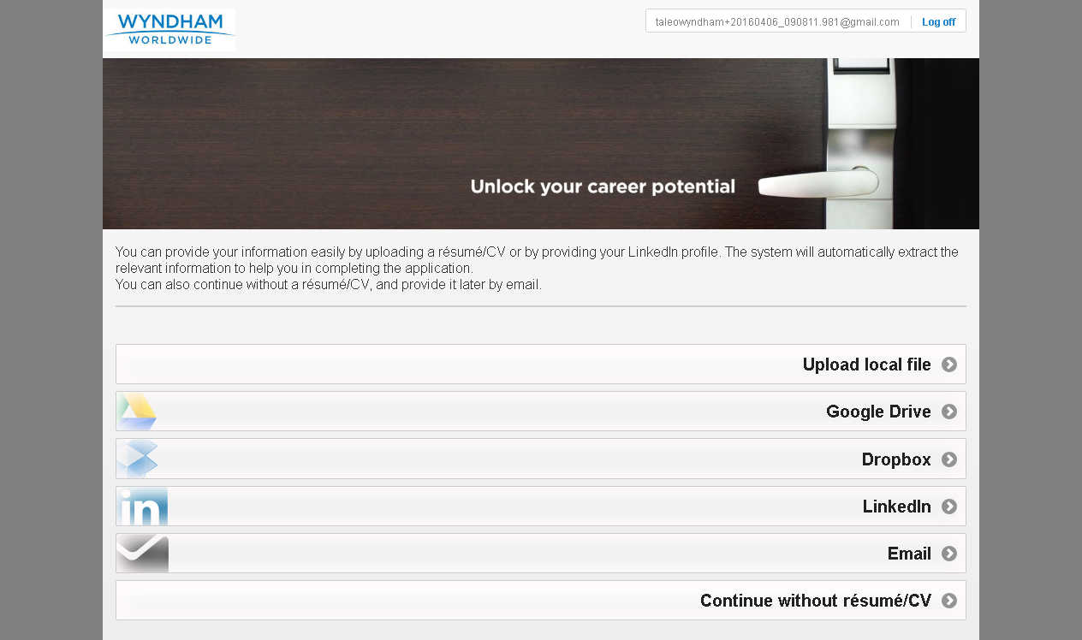

MobileTestingScenario_runTestScenario_Instance3_06-Apr-2016_09-08-52_AM_Dropbox_Option.png

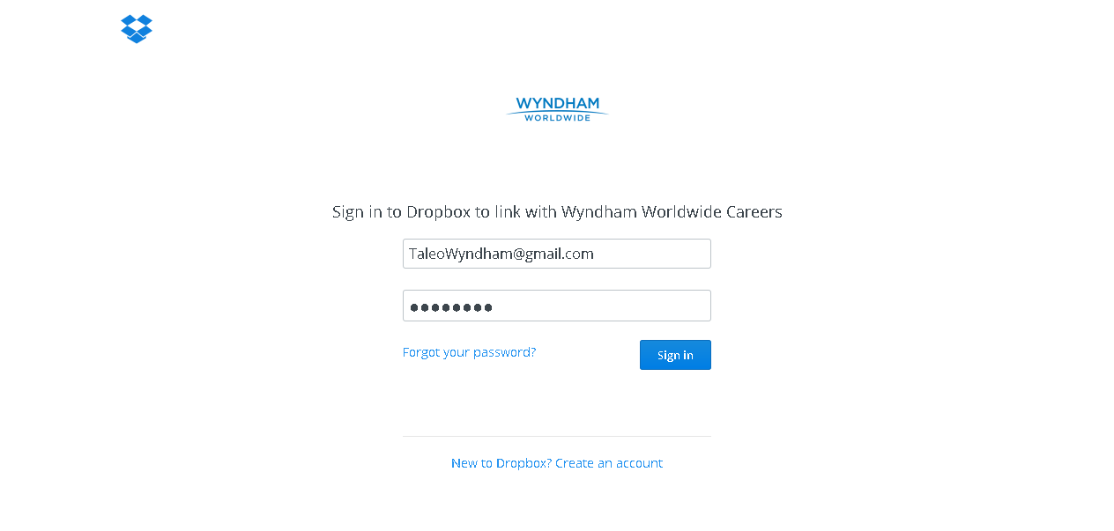

MobileTestingScenario_runTestScenario_Instance3_06-Apr-2016_09-09-10_AM_Dropbox_Option.png

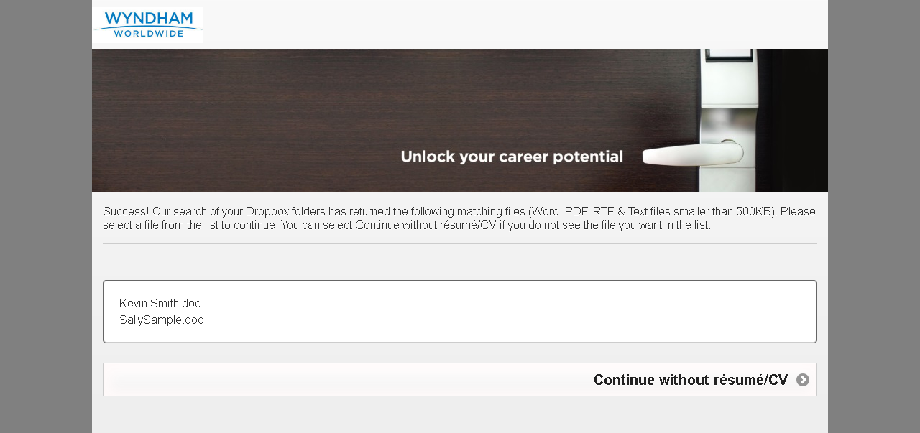

MobileTestingScenario_runTestScenario_Instance3_06-Apr-2016_09-09-15_AM_Dropbox_Option.png

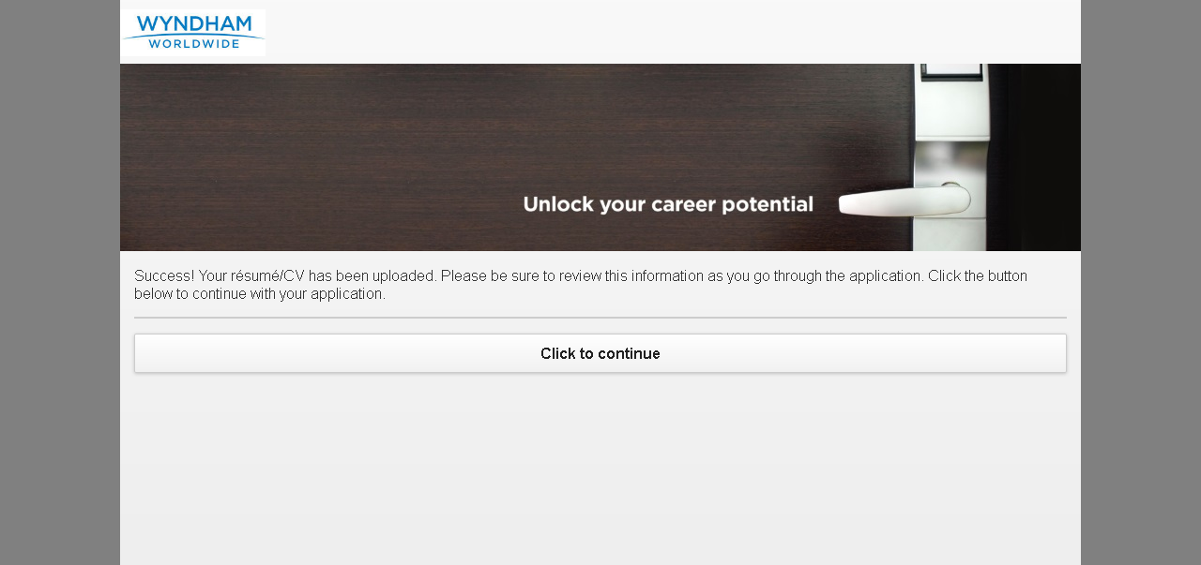

MobileTestingScenario_runTestScenario_Instance3_06-Apr-2016_09-09-59_AM_Tell_us_about_yourself.png

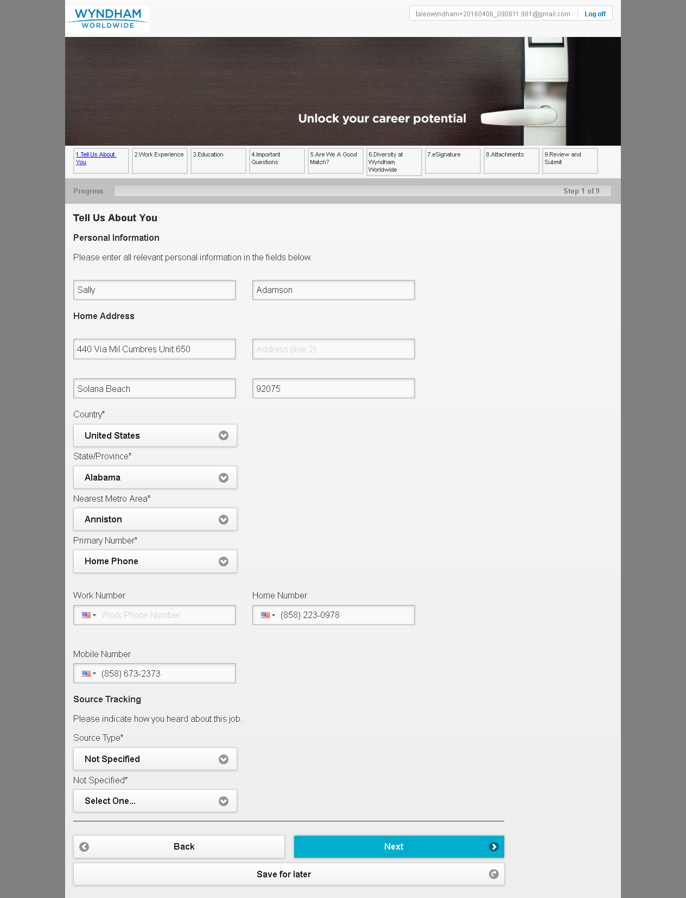

MobileTestingScenario_runTestScenario_Instance3_06-Apr-2016_09-10-11_AM_Tell_us_about_yourself.png

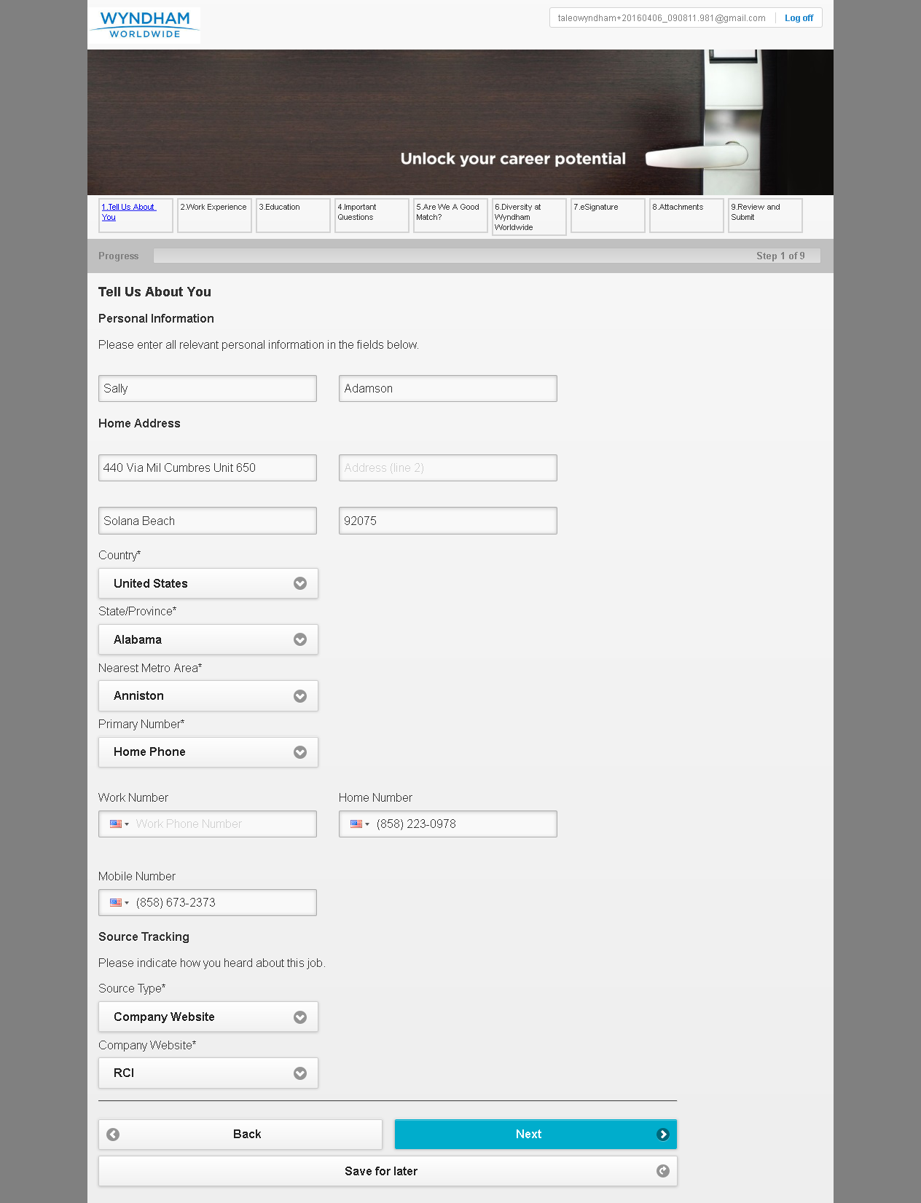

MobileTestingScenario_runTestScenario_Instance3_06-Apr-2016_09-10-24_AM_Work_Experience.png

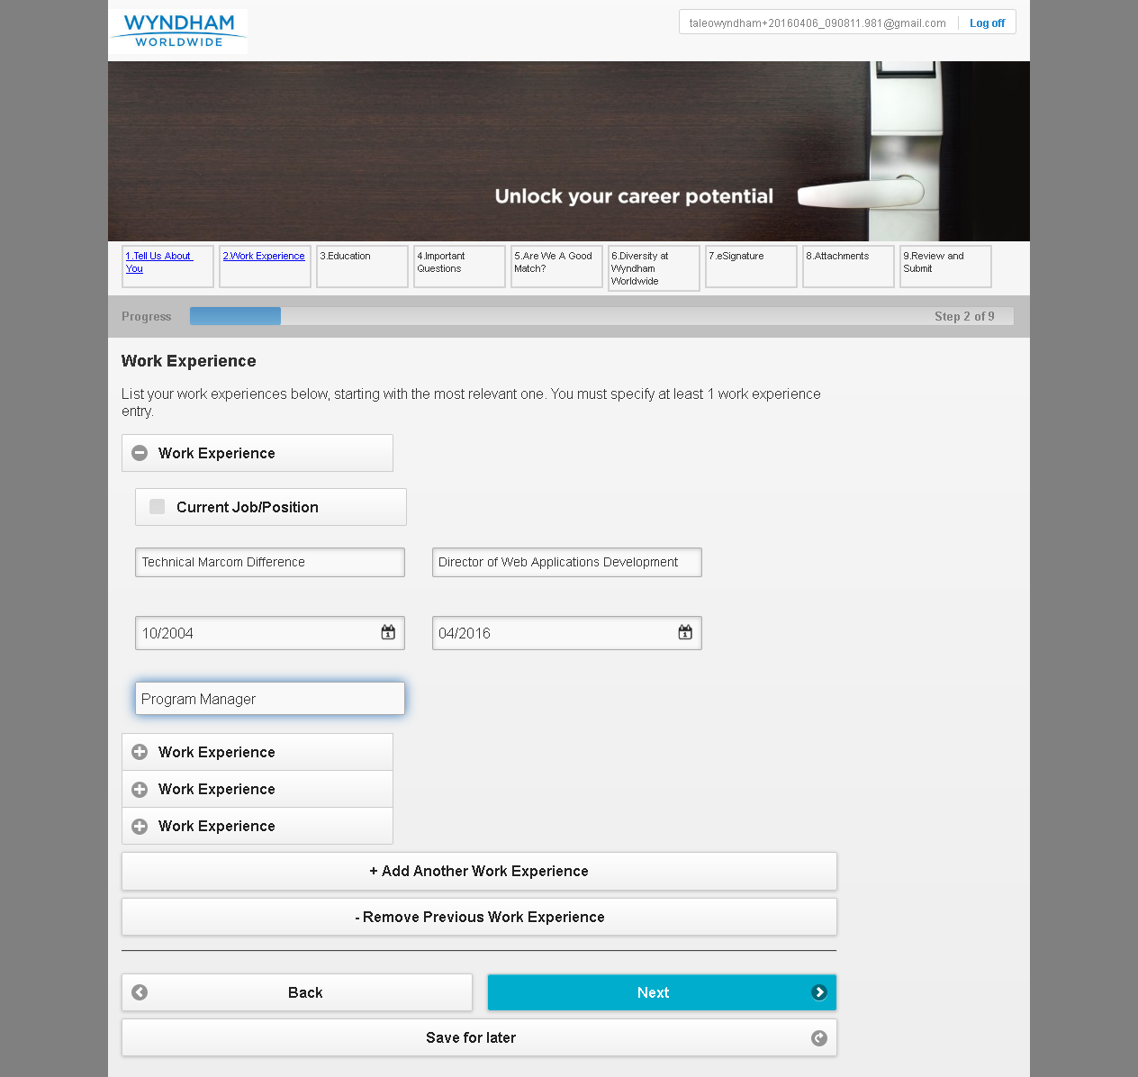

MobileTestingScenario_runTestScenario_Instance3_06-Apr-2016_09-10-41_AM_Education.png

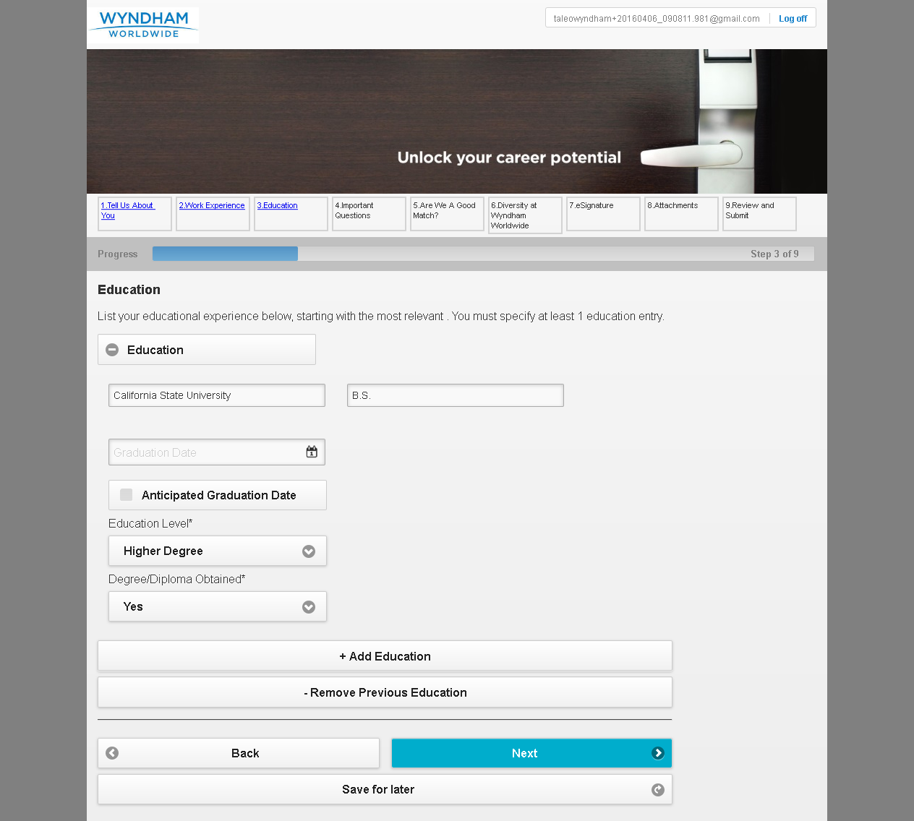

MobileTestingScenario_runTestScenario_Instance3_06-Apr-2016_09-10-48_AM_Questions.png

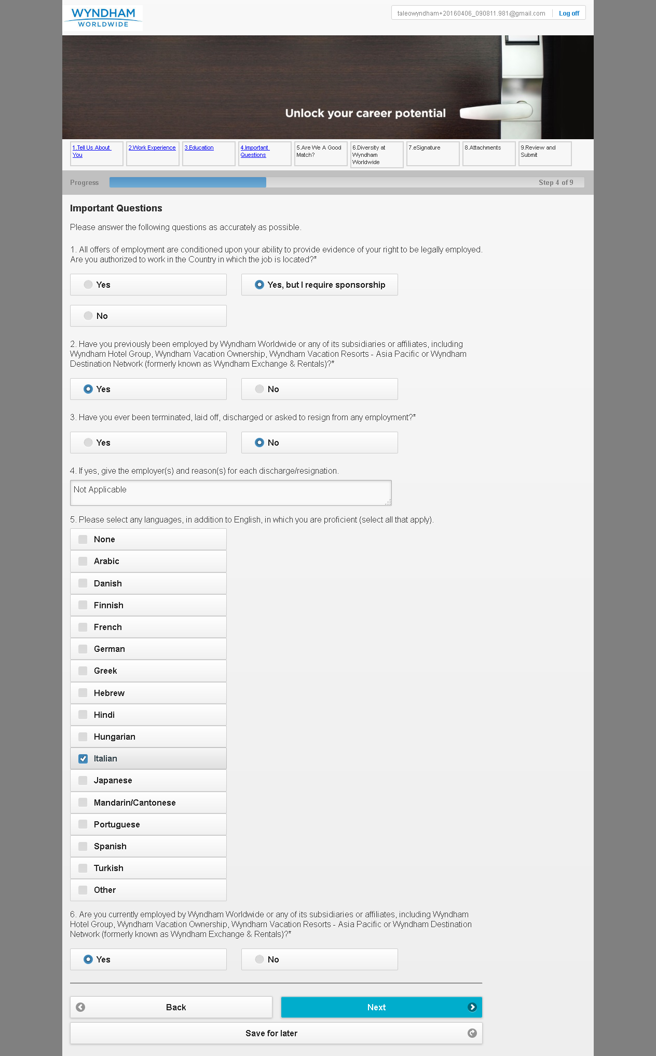

MobileTestingScenario_runTestScenario_Instance3_06-Apr-2016_09-11-02_AM_Are_we_good_Match.png

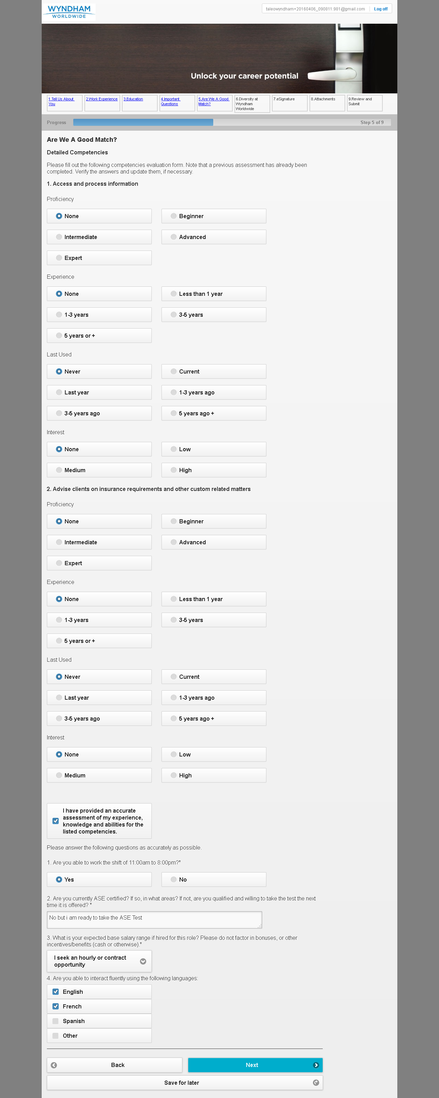

MobileTestingScenario_runTestScenario_Instance3_06-Apr-2016_09-11-26_AM_Diversity.png

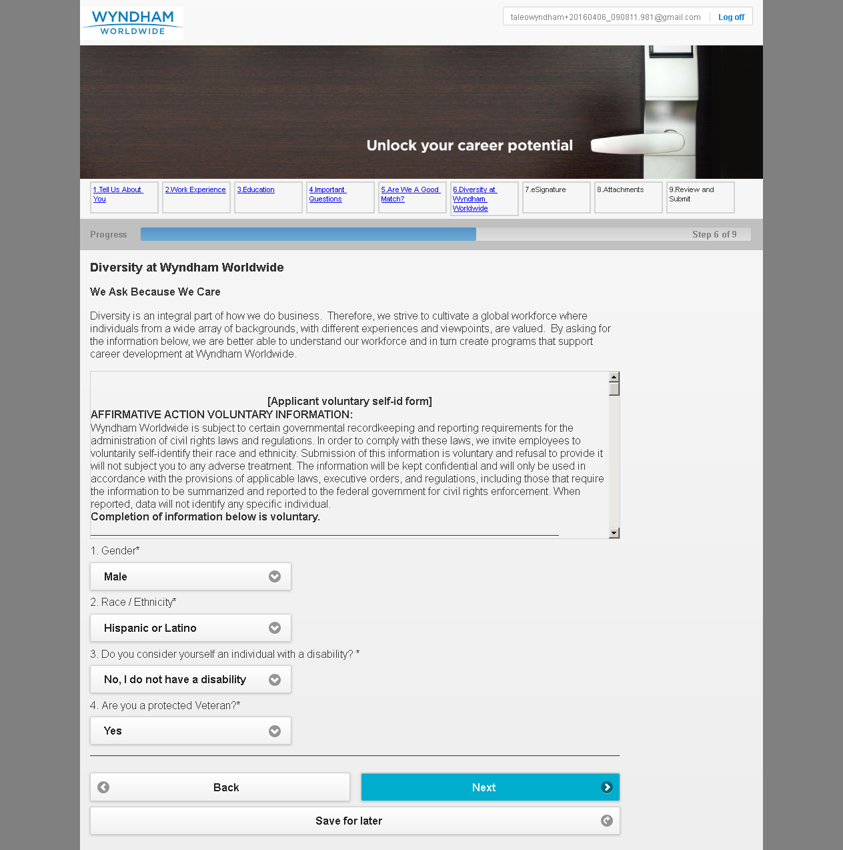

MobileTestingScenario_runTestScenario_Instance3_06-Apr-2016_09-11-34_AM_eSignature.png

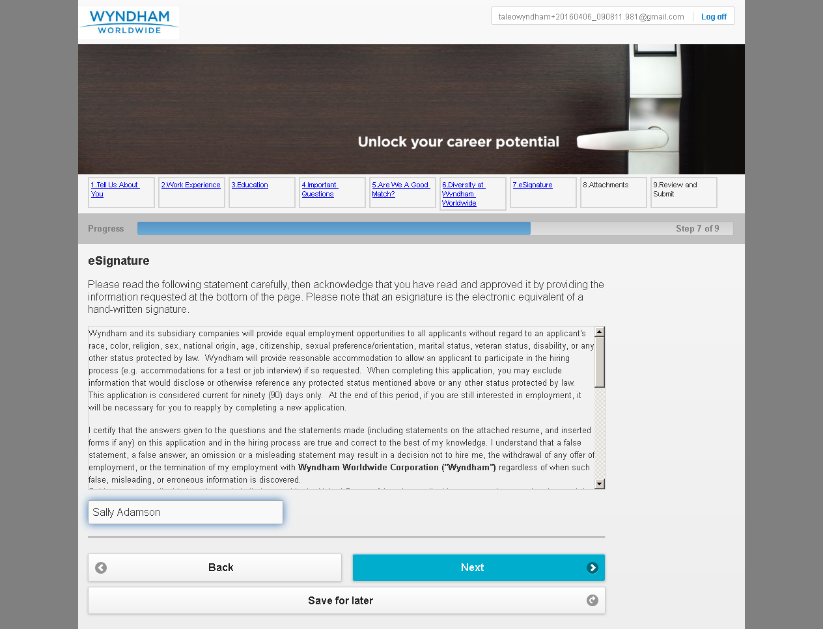

MobileTestingScenario_runTestScenario_Instance3_06-Apr-2016_09-11-40_AM_Attachment.png

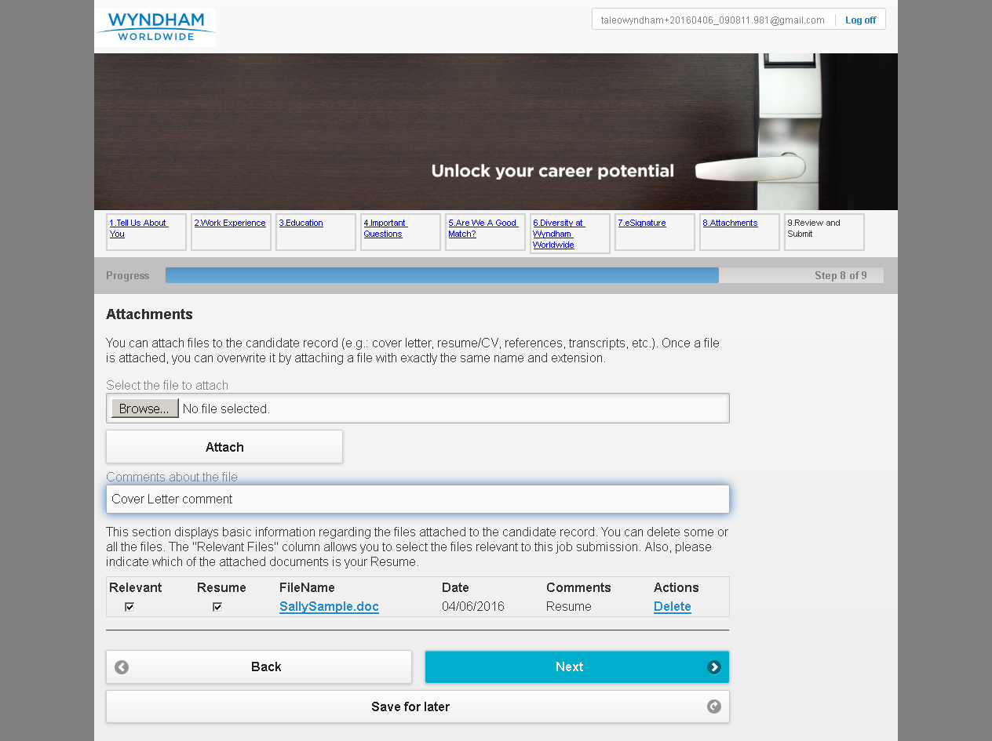

MobileTestingScenario_runTestScenario_Instance3_06-Apr-2016_09-11-51_AM_Review_and_Submit.png

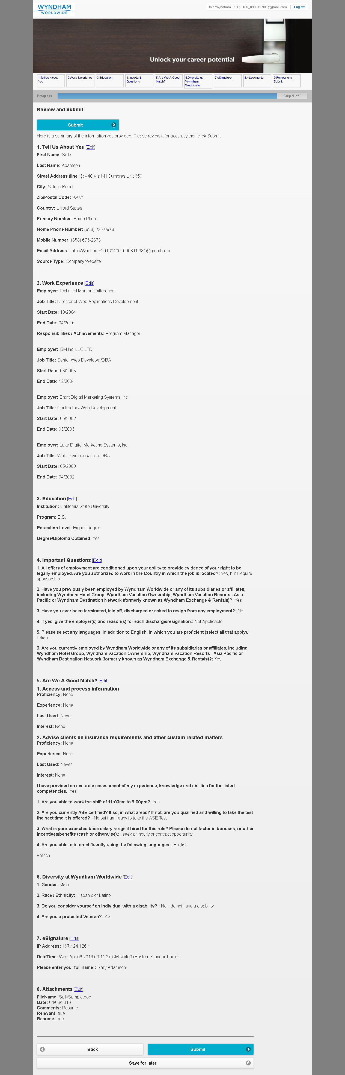

MobileTestingScenario_runTestScenario_Instance3_06-Apr-2016_09-12-02_AM_Application_Completed.png

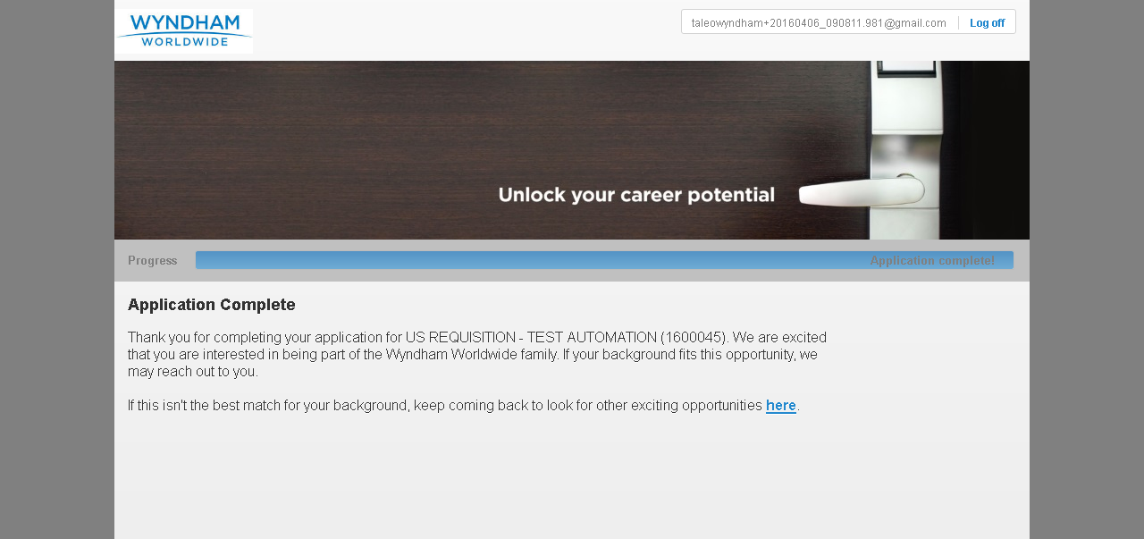

MobileTestingScenario_runTestScenario_Instance3_06-Apr-2016_09-12-14_AM_CRM_Loop_Validation.png

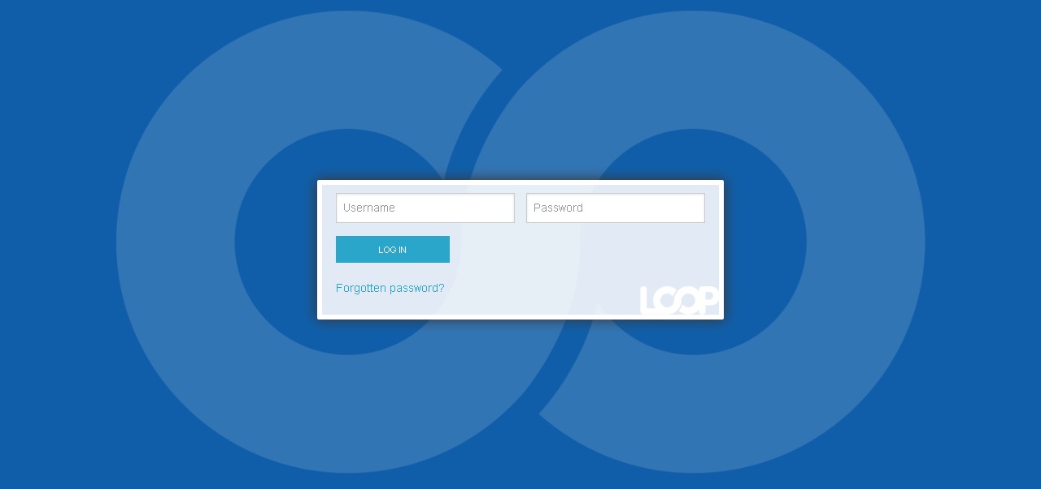

MobileTestingScenario_runTestScenario_Instance3_06-Apr-2016_09-12-22_AM_CRM_Loop_Validation.png

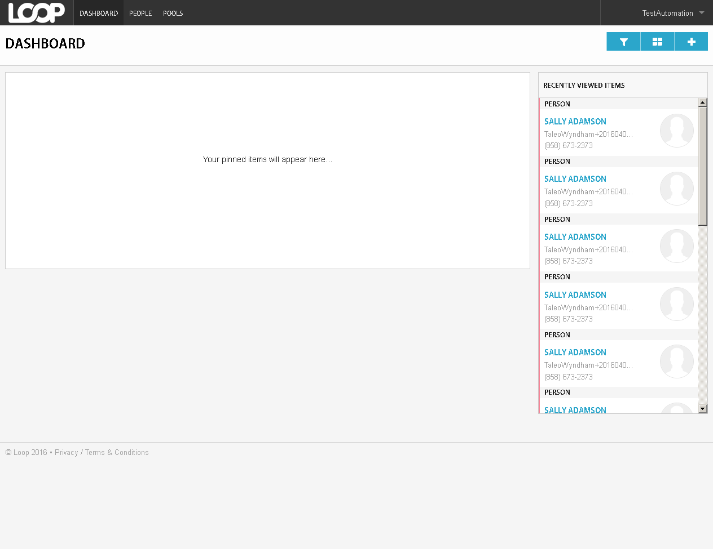

MobileTestingScenario_runTestScenario_Instance3_06-Apr-2016_09-12-43_AM_CRM_Loop_Validation.png

